# EARTHQUAKE PREDICTION MODEL USING PYTHON

**INTRODUCTION**

The problem is to implement Artificial Intelligence Techniques for Earthquake prediction based on latitude, longitude, time, date and type. The goal is to enable fast prediction of earthquakes to prevent disasters. This project involves data collection, data pre-processing, feature engineering, clustering algorithms, visualization, and interpretation of results.

In this phase the building to innovation and data flow of customer segmentation is going to be done.

**PREREQUISITES FOR BUILDING A CUSTOMER SEGMENTATION MODEL**

* The data is obtained from [https://www.Kaggle.com/data](https://www.kaggle.com/data)
* Have the following libraries installed — Numpy, Pandas, Matplotlib, Seaborn
* Columns Required from dataset

1. Date
2. Time
3. Latitude
4. Longitude
5. Type

**UNDERSTAND THE SEGMENTATION DATA**

Before starting any data science project, it is vital to explore the dataset and understanding each variable.

Libraries Imported :

1. Numpy
2. Pandas
3. Matplotlib
4. Seaborn

Loading the Data

1. **df=pd.read_csv(‘/kaggle/input/earthquake-prediction/database. csv’)**

Let’s look at the head of the dataframe:

**COLUMN**

data = data[['Date', 'Time', 'Latitude', 'Longitude', 'Depth', 'Magnitude']]

data.head()

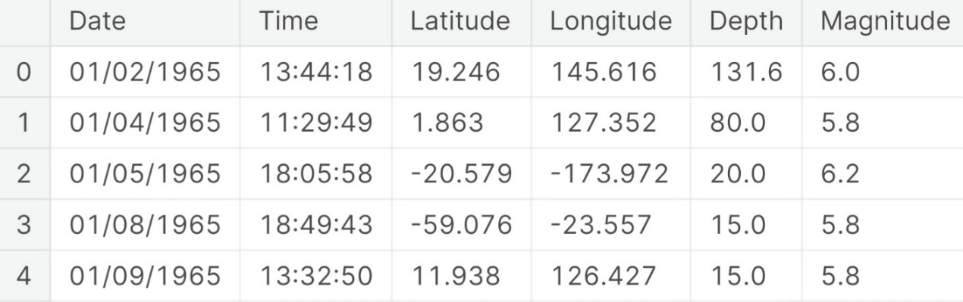

import datetime

import time

timestamp = []

for d, t **in** zip(data['Date'], data['Time']):

try:

ts = datetime.datetime.strptime(d+' '+t, '%m/**%d**/%Y %H:%M:%S')

timestamp.append(time.mktime(ts.timetuple()))

except **ValueError**:

*# print('ValueError')*

timestamp.append('ValueError')

timeStamp = pd.Series(timestamp)

data['Timestamp'] = timeStamp.values

final_data = data.drop(['Date', 'Time'], axis=1)

final_data = final_data[final_data.Timestamp != 'ValueError']

final_data.head()

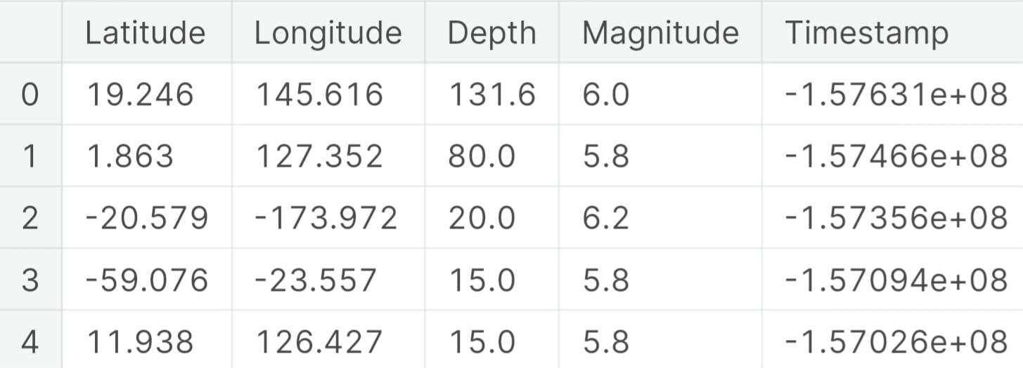

## Visualization

from mpl_toolkits.basemap import Basemap

m = Basemap(projection='mill',llcrnrlat=-80,urcrnrlat=80, llcrnrlon=-180,urcrnrlon=180,lat_ts=20,resolution='c')

longitudes = data["Longitude"].tolist()

latitudes = data["Latitude"].tolist()

x,y = m(longitudes,latitudes)

fig = plt.figure(figsize=(12,10))

plt.title("All affected areas")

m.plot(x, y, "o", markersize = 2, color = 'blue')

m.drawcoastlines()

m.fillcontinents(color='coral',lake_color='aqua')

m.drawmapboundary()

m.drawcountries()

plt.show()

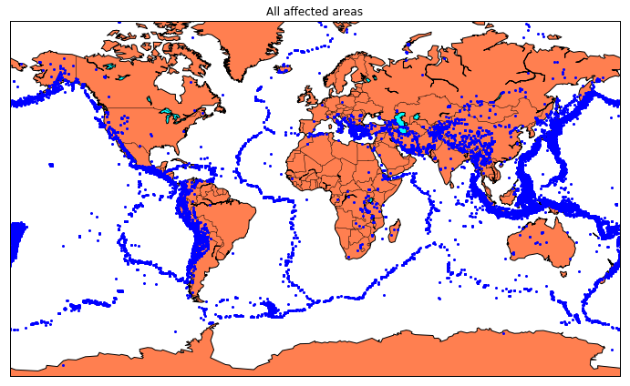

### Splitting the Data

X = final_data[['Timestamp', 'Latitude', 'Longitude']]

y = final_data[['Magnitude', 'Depth']]

from sklearn.cross_validation import train_test_split

X_train, X_test, y_train, y_test = train_test_split(X, y, test_size=0.2, random_state=42)

print(X_train.shape, X_test.shape, y_train.shape, X_test.shape)

from sklearn.model_selection import GridSearchCV

parameters = {'n_estimators':[10, 20, 50, 100, 200, 500]}

grid_obj = GridSearchCV(reg, parameters)

grid_fit = grid_obj.fit(X_train, y_train)

best_fit = grid_fit.best_estimator_

best_fit.predict(X_test)

best_fit.score(X_test, y_test)

**NEURAL NETWORK MODEL**

from keras.models import Sequential

from keras.layers import Dense

def create_model(neurons, activation, optimizer, loss):

model = Sequential()

model.add(Dense(neurons, activation=activation, input_shape=(3,)))

model.add(Dense(neurons, activation=activation))

model.add(Dense(2, activation='softmax'))

model.compile(optimizer=optimizer, loss=loss, metrics=['accuracy'])

return model

grid = GridSearchCV(estimator=model, param_grid=param_grid, n_jobs=-1)

grid_result = grid.fit(X_train, y_train)

print("Best: **%f** using **%s**" % (grid_result.best_score_, grid_result.best_params_))

means = grid_result.cv_results_['mean_test_score']

stds = grid_result.cv_results_['std_test_score']

params = grid_result.cv_results_['params']

for mean, stdev, param **in** zip(means, stds, params):

print("**%f** (**%f**) with: **%r**" % (mean, stdev, param))

[test_loss, test_acc] = model.evaluate(X_test, y_test)

print("Evaluation result on Test Data : Loss = **{}**, accuracy = **{}**".format(test_loss, test_acc))

model.save('earthquake.h5')

**DESIGN**

